Wise Words
Gary Wise
Here's the thing about column work: life is just so much easier when your article falls in your lap. In preparing for GP Boston, I was doing my online regimen of kicking up Netdraft, advertising on 5 some-odd IRC channels and thinking only about my first few picks (Once colors have been established, the rest should be clockwork if you know the cards) when faced with an interesting dilemma.

"The only style you should use is good drafting" -Dan O'Mahoney-Schwartz
My first pick was an easy one, with Tsabo's Decree, the easy to cast, instant speed powerhouse appearing at the top of my screen. With the only comparable card in the pack being Thornscape Apprentice, I chose the rare, as I'll often do on Netdraft as it allows me to experiment with those cards I don't get to build a deck around every day. Double clicking on the Decree, I was then faced with a really difficult decision.
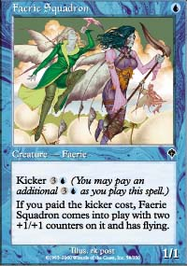
The next pack (forgive me for not recording all the contents, I had no clue that this would turn into an article) contained three cards of note: Faerie Squadron, Duskwalker and Hate Weaver. Now, Blue-Black is definitely my favorite color combination right now. The synergy of bounce and discard sends chills up my spine. I like flyers, I like black removal, and I LOVE casting Probe with the kicker. Additionally, I've been having trouble lately with the red-black archetype. It seems that whenever I draft it, things start out strong but I get wrecked in the 2nd and 3rd packs, be it because those players drafting after me are forcing/hoping for those colors, or because the dimwit in front of me opens Flametongue Kavu or Magma Burst and decides to diversify his or her mana a little. Regardless, while normally I would like to leave myself the option of RB, with Boston so close (this was on the Thursday before), I wanted to draft in a way that most closely resembled what I'd do at the GP.
In paring down the selection to two cards, I eliminated Hate Weaver in that my UB decks are usually based more on the bounce/discard mechanic than beatdown, meaning that Duskwalker suited the archetype better (this is not to say the Walker is the better card. Hate Weaver is actually the better of the two, but I really just want to eliminate it from this discussion in getting to my point). With the competition down to two cards, I had to weigh them against one another. I've heard it said that Duskwalker may be as good as the Squad, but against other black decks its little more than an Attendant, and the Walker can't ever block flyers. Faerie Squadron controls the sky, and while yes, it can be Banished, the fact that its equally effective against black and non-black decks clearly makes it the superior card.
So with that in mind, I had to make a decision regarding whether I wanted to sacrifice a little card quality in order to keep my options open, or if I wanted to 'declare' (a mostly pointless endeavor in Booster Draft) my second color. Understanding that I was still left the option of going UW with a splash for Decree or UB with a potential to splash either red kill or white tappers, I chose the Squadron.
Not entirely convinced I'd made the right choice, I went back to IRC and posed the question to a chat room full of pros. The logic went that, with both Duskwalker and Hate Weaver in the pack, it was impossible to cut off black while the Squadron, the only strong blue card I'd seen to that point, could allow me to cut off blue. In addition, with my tastes suggesting I'd eventually go blue anyways, the question lingered as to whether passing the Squadron would do more damage to me than hoped, with its eventual owner taking most of 'my' blue in pack two, thus hurting the overall strength of my deck if it ended up in those colors.

So I asked into the void of IRC if taking the Squad was the right play. I stared at the empty whiteness of the empty chat room for an eternity in need of an answer. Finally, I got one.
"You're an idiot"
Dan O'Mahoney-Schwartz had come forward with his opinion. Using the age-old axiom 'keep it simple, stupid' Dan reasoned that with the differences between the Walker and the Squad being negligible, my main concern was establishing myself in a color, and therefore the black card was the obvious choice. I explained to Dan that I wasn't a big fan of RB (I can't believe I'm saying that. The RB commons in Planeshift are insane and the deck was good before the new set was introduced) and that I hadn't been going 3-0 with said deck, mostly because I felt it didn't fit my style of play. At this point, Dan made a comment that makes a lot of sense to me:
"The only style you should use is good drafting"
What Dan meant is that there's a right way and a wrong way to approach draft, and to allow personal taste to interfere with that was a mistake. With that logic in tow, conventional wisdom suggests that the longer one keeps their options open, the better their eventual choices will likely be, so following the first pick Decree with the black card was the right way to go. Were DanO right, one would have to agree with this thought as keeping options open is a good thing and the loss of quality in the walker/squadron decision is negligible.
The question, then is whether he's right. Not about the color integrity issue, mind you. One should definitely stick to colors as much as possible as bad mana affects more duels than any of us want it to. There's no question that if you have no preformed notions, you should be keeping your color options open as long as possible. Unfortunately, preformed notions come as part of the human experience, and that means ignoring the fact they exist hardly develops an accurate handle on a situation.
I'm not entirely sure that developing preformed notions is all that wrong. Understanding your own strengths and weaknesses can prove to be a strength. If Dave Price knows he plays Sligh as well as anyone but isn't comfortable with a combo deck, it wouldn't be too smart of him to play combo when Sligh is an option. Likewise, in draft, each color combo is akin to a Constructed archetype, with each pick one makes reflecting on one's understanding of those archetypes. I know I like discard and bounce. I know I like BU.

There are no single color decks and one must make both color distinctions as quickly as possible...
With all this in mind, we go back to the IRC conversation. Chris Pikula contributed in his understated way, suggesting my pick may not be as wrong as Dan was proclaiming. Chris's reasoning went that in this format, there are no single color decks and one must make both color distinctions as quickly as possible, with failure to do so possibly resulting in your neighbors taking the other four colors. With your goal in draft essentially being to isolate yourself as much as possible from those around you, the question then becomes how you want to do that.
The nature of Invasion Draft is that most players want to be in either black or red. From the second pack, the guess is that the player passing to me wasn't in black after his first pick, but with no playable red, its possible that they took a red card. Additionally, they passed a Faerie Squadron, which more often than not will mean that they won't be going into blue. In other words, blue was literally right there for the taking.
Eventually both Sigurd Eskeland and Jon Finkel chipped in saying the black card was the right pick. If this had all happened a week before a major event, I'd have to agree, with that week providing time to straighten myself out as far as teaching myself to draft the RB archetype better. That said, I guess the point is this: know thyself. I was two days away from a major event and uncomfortable with RB. That means that drafting UB or WU with a splash for Decree were my other options, and for either of them, Squadron was the card I wanted. I stand by the pick.
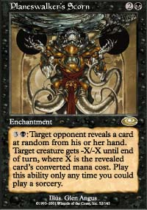
I stole this little story out of Boston right out from under Alex Shvartsman's nose. Drafting on more than 30 sleepless hours, PT Chicago '99 finalist Brian Davis made one of the greatest goofs in history. Playing against Hashim Bello, Davis had in play two creatures and a Planeswalker's Scorn, while Bello had 6 cards in hand but no creatures in play.
Feeling firmly in control, Davis served for four points of damage and looked at his hand with the realization that he had nothing to cast. With an abundance of mana, he decided to try to gain some insight into Bello's hand. Saying 'I guess I'll look at a card,' Brian activated his Scorn without declaring a target. Bello started laughing at a confused Davis, clarifying the confusion by explaining that the Scorn needed a target. Davis, failing to realize that the mana was therefore still in his pool, chose one of his creatures instead of taking into account the possibility of taking 4 points of burn. He didn't win the game. Don't think the pros aren't capable of making the same mistakes you do. Or worse.
From a Player of the Year perspective, this weekend's biggest story was Scott Johns intensifying the hunt for the title. A member of the Potato Nation team that won New York, Johns, coming into the weekend at 40 points on the season, added five more with his 2nd place finish in Boston, leaving him 10 points back of leader Mike Pustilnik. Also attending Boston among the top 10 in this year's race were Johns' Nation teammates Mike Turian and yours truly, with Mike collecting an extra PT point while I crashed, burned, disintegrated and incinerated.
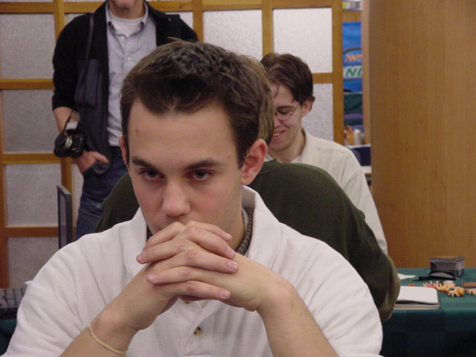
Meanwhile in Europe, that continent's finest jostled for position near the bottom of the top ten. While both Kamiel Cornelissen and Kai Budde failed to make a PT point dent, Antoine Ruel's second place finish put him in ninth place in the Player of the Year race with 27 points, while Benidikt Klauser, who finished out of the points in Cologne, barely stayed on the list, with Chris Benafel's 3 points in Boston and Noah Boeken's 2 points in Germany leaving the three in a tie for tenth.
Among those in the top 10, only three didn't compete this weekend. Jon Finkel continued to ignore GP play, skipping the closest GP to his New York base of the season, while Rob Dougherty served as tournament organizer for GP Boston, disqualifying him from eligibility to play. With 589 players in his tournament, I'm sure Dougherty is happy with his decision.

You can't stop this guy!
The last player in the top ten, also missing out on this weekend's festivities was the Player of the Year race leader, Mike Pustilnik. Despite the proximity of Boston to his New York home, Mike, a more diverse gamer than most M:tG pros, was out of town attending the Titan National championships in Charlottesville, Virginia. While some might take this as an affront to Mike's goals, Dr. P proved it was more than worth his while, winning the tournament and the US Championship crown.
'I didn't really expect to win, there were a lot of really good players there' Mikey told me when I talked to him, but apparently the New Yorker can't do too much wrong as far as games go these days. With the Championship firmly in his pocket, Mikey now turns his attention back to Tokyo and preparing with Alex Shvartsman, where he'll try to hit his third Top 8 in a row along with Finkel and Cornelissen, matching Scott Johns three-peat from the Pro Tour's first season.
Well, that's about it for this week folks. As always, get in touch with me at JgaryWise@yahoo.com with any questions or comments you may have with regards to the column. Have a good week.

